‘This quirky oasis of a theatre is a charming hidden gem in South London.’
Everything Theatre

Dear Applicant,

Thank you for your interest in this important role at the Blue Elephant Theatre, well described by Everything Theatre as a ‘charming hidden gem’ providing an oasis of creativity and imagination at the heart of Camberwell. Please see below some images of our recent and current work.

The Participation and Co-Artistic Director role has wide-ranging responsibilities in this small but exciting organisation: everyone who works at the Blue Elephant has an impact and makes a contribution to its future, but especially the holder of this post. For more information about this see the note from the current holder of the post at the end of the job description.

Trustees aim to support the successful applicant to make this role their own and assist them in making their own contribution.

We hope this appeals to you and we look forward to reading your application.

Best wishes,
Chris Lawrence,
Chair of Trustees

c. Lidia Crisafulli

Blue Elephant Theatre Job Description:

Participation & Co-Artistic Director

About the Theatre
Opened in 1999, the Blue Elephant Theatre is a small but vibrant arts venue that aims to widen access to creative opportunities. We have imaginative and engaging professional and participation departments and aim to link up both as often and meaningfully as possible. BET became an NPO in April 2018 and has been supported by Southwark Council since it opened. We support emerging and independent artists as they create and present new work, offering creative, marketing and fundraising support as well as in kind rehearsal space and box office splits. We programme work across art forms but particularly theatre, dance and comedy and have a focus on developing shows for young people.
Our work with young people has received significant funding from BBC Children in Need for fifteen years (as well many others), supporting young people in the local community to increase their self-confidence, self-belief and social skills. We have an enviable reputation within Southwark for excellence in participatory theatre. We work with schools as well as a wide variety of community partners to deliver high quality sustained opportunities to young people who may not ordinarily take part.
We also have a burgeoning adult participatory programme of activities, supporting mental health and community cohesion. This strengthens the eclectic mix of activities happening at the theatre, proving the theatre’s growth mindset.

c. A Kin Photography
Participation & Co-Artistic Director

Nature of the post
This is a vital role within the organisation, with responsibility for day to day management, strategic leadership and artistic direction of the Participation Department, working closely in collaboration with the Executive & Co-Artistic Director/ senior leadership team. This role will require delivery of some of the projects and over-arching management of them all.

Contract: One year full time fixed term contract initially with the expectation of being renewed as a permanent contract subsequently.
Salary: £31,200 gross
Hours: 37.5 hours p.w.
Holiday: 28 days p.a. (including public and bank holidays)

First Round Interviews: 8th April during daytime hours. These interviews will be held via Zoom
Second Round Interviews: 13th April These interviews (plus workshop) will be held in person at Blue Elephant Theatre
Closing date for applications: March 25th at 12pm

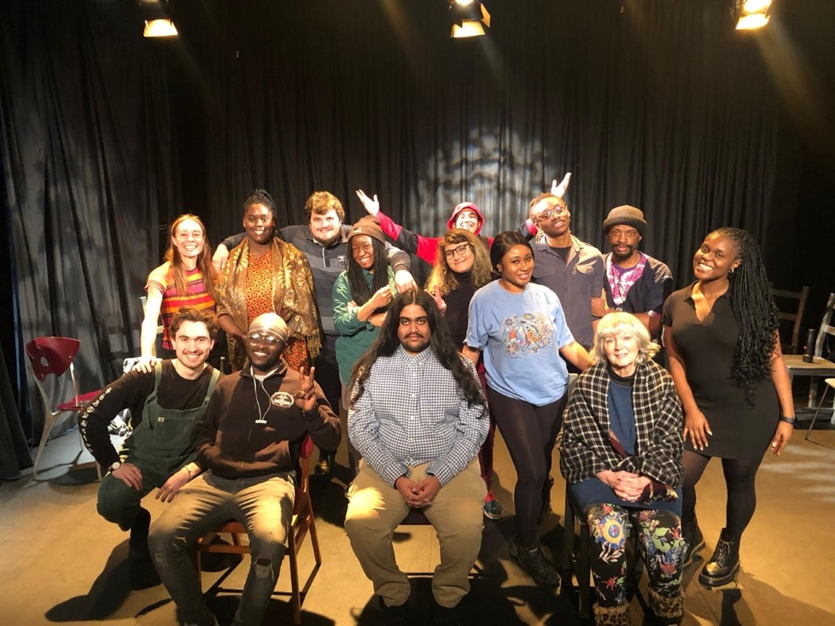

Duties and Responsibilities

The Participation & Co-Artistic Director is responsible for ensuring the following takes place:

Project Delivery
- The day to day effective management of all of the projects, including ensuring compliance with health & safety requirements and safeguarding requirements (both in BET and other settings).
- Leading on the delivery of specific projects including Creative Minds and the Public Health Grant (see full list and description of projects below). More delivery may be required as the needs of the department shift.
- Overseeing other participation staff in delivery their projects (taking place on evenings and weekends). This includes administrative management, as well as presence at some of the workshops.
- Strategic development of the department, including project creation, developing partnerships within the wider community and working in collaboration with Executive and Co-Artistic Director to ensure the work of the whole theatre remains relevant.

Safeguarding
- Acting as lead Safeguarding Officer for the organisation and ensuring that good practise is being followed at all times.
- Ensuring that staff and volunteers undertake a DBS check.
- Being a point of contact during each planned activity in case of an emergency.

Finance
- The financial and administrative operations of the Participation department, (in collaboration with the Executive Director), including setting the budgets, monitoring expenditure, requests and receipt of funds & reporting to trustees.
- Identifying financial issues or needs.

Personnel & HR
- HR management and line-management of participation staff members and volunteers, (including regular appraisals and assessment).
- In collaboration with the Executive Director, ensuring staff members have up to date contracts, induction on starting roles, required training, pension paperwork etc
- Active involvement in the recruitment of personnel, ensuring opportunities are shared widely and made as accessible as possible
- Actively promoting equal opportunities throughout the theatre
- Provide pastoral support for staff members

Funding
- Supporting Executive & Co-Artistic Director on ensuring BET meets all the conditions and requirements of our NPO funding from Arts Council England
- In collaboration with the Executive Director, developing and maintaining relationship with appropriate funding organisations.
- Research new avenues of funding where needed.
- Submit relevant fund applications
- Ensuring funding offers are accepted in a timely manner, that conditions of funding are met and reports are submitted on time
- Ensure that invoices have been sent and finance has been received.

Misc
- Acting as a key holder and supporting where necessary the activities of the rest of the theatre.
- Supporting the strategic development of Blue Elephant Theatre at an exciting time as it expands capacity and output after multiple lockdowns
- Managing projects as they arise.
- Supporting the artistic output of BET as appropriate.
- Undertaking any other duties which need to happen
- Undertaking additional delivery of projects to support staff absence, when necessary
- Supporting the implementation of BET’s Business plan (including Equality Action Plan & Environmental Action Plan), including its aim to be a safe space which supports the expression of creativity. This safe space is:

- Somewhere artists can try new ideas, techniques and approaches, cushioned by BET’s support mechanisms.
- Somewhere local communities, particularly young people, feel safe to express themselves creatively and explore issues troubling them or that arise in their lives. At times, it is a safe space from troubles in their lives and BET staff take safeguarding young people and vulnerable adults extremely seriously.
- Somewhere inequality, discrimination and bullying is neither tolerated nor ignored. BET aims to set a standard for what it means to be a friendly, collaborative workplace which values employees, artists and other workers within BET alike.
- Somewhere audiences feel is “for them” regardless of their background and previous familiarity with the arts.

The Participation & Co-Artistic Director has a responsibility to maintain and support this safe space. BET is committed to ensuring all employees find BET a safe space to work within and will give any grievances or concerns due attention.

The above list is not exhaustive and reasonable duties may be added to it.

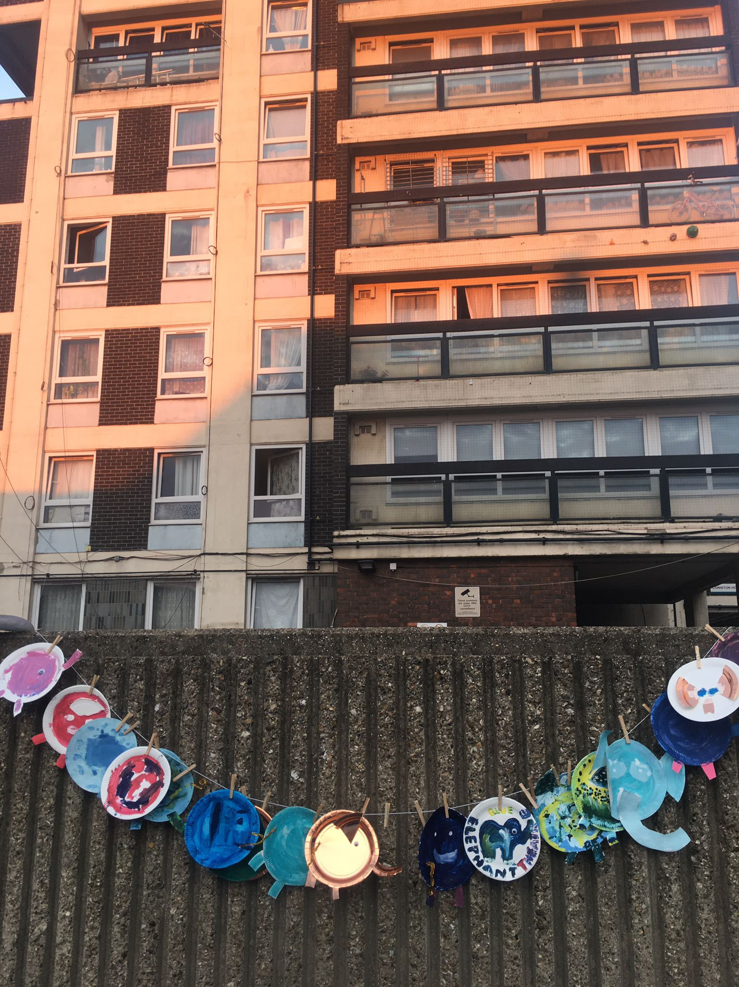

List of projects delivered:

Young people:
- Creative Minds: On-going primary school-based workshops to support curriculum learning, as well as after school clubs.
- Healthy Minds: An arts-based approach to supporting the additional mental health needs of designated young people in a primary school.
- Young People’s Theatre: Youth theatre for spanning the ages of 7-18 on Saturdays.
- Free to Act: Youth theatre spanning the ages of 7-15 on Thursdays.
- Playing Up: Workshops for children aged 1-3 and their adults, focusing on the power of play.
- Speak Out: A forum theatre project touring across secondary schools to tackle pertinent issues.

Adults:
- Community Play: An arts opportunity for local residents to create meaningful work.
- After Hours: An opportunity for hyper local 18-25 years olds to create community focused theatre.
- Public Health Arts: (Parent & Child, Social Dance, Adult Drama): Arts projects for adults to support mental and physical well-being.
- Train In Work: A paid training a work opportunity for 18-25 year olds in the art of facilitation.
- SELNWK Elephants: Arts projects for adults with acquired brain injury in partnership with Headway.

BET also responds to the needs of the community and creates bespoke ad-hoc work according to need and upon request.

c. Lidia Crisafulli

Person Specification

Essential:

- Can demonstrate strong experience working in an arts participation role(s) with similar responsibilities (three years minimum).
- Experience of working with under-served communities who experience barriers to the arts.
- A desire to champion diversity in the arts and active commitment to make the arts accessible to all
- Experience of responsibility for Safeguarding.
- Strong track record in fundraising, including applications and reporting to trusts and foundations.
- Experience in the development and delivery of a project from its first inception to final reporting.
- Excellent interpersonal and communication skills, including verbal and written.
- Experience of financial management
- Strong administration and IT skills
- Ability to multi-task and meet numerous conflicting deadlines
- Current DBS check

Desirable:
- First aid training within the last three years
- Safeguarding trained within the last 3 years
- Experience of reporting as an Arts Council NPO

Working days are typically Mondays to Fridays from 10am to 6.30pm with an unpaid lunch break but there is a lot of flexibility as weekend and evening work can happen frequently. At present, the post-holder will be expected to work on Thursday early evening and Saturday day times, as necessary. Overtime is not paid but the post-holder is expected to take Time Off in Lieu as far as is possible.

The Blue Elephant Theatre welcomes applications from all sections of the community regardless of race, ethnic or national origins, marital status, sex, sexual orientation, disability or religious beliefs.

Blue Elephant Theatre is committed to widening access to the arts and when recruiting we reserve the right to guarantee interviews to applicants referred by partner organisations provided they meet the essential criteria and complete an application form.

Please note BET's theatre space is wheelchair accessible but our office upstairs is not. We do not want this to deter potential applicants as we would seek to work together to find a practical working solution should the person appointed be a wheelchair user.

Note from Jo- Outgoing Participation and Co-Artistic Director

Leaving this role has been a very tough decision for me as simply put, I have loved my time with Blue Elephant! I have worked with the theatre in some capacity for 13 years and I have found the ever-changing opportunities captivating, rewarding and full of joy. The department has grown and developed into a multi-faceted and vibrant example of excellence in participatory arts. We have some amazing projects that are a privilege to be a part of and opportunities to develop in a wide variety of ways. The ability to switch between polarized tasks is vital. A day can go from early morning project delivery with 5 years olds, to writing a funding application in the afternoon and working with aged 18+ participants in the evenings. A lot of this role requires quick thinking and the ability to trust your own instincts. There is limited time afforded to workshop planning so being very at ease in this setting is essential. We employ a variety of staff who have expertise in their specific areas but if someone is sick or absent, the Participation Director is expected to step in where possible.

The work can be challenging as we specifically set out to provide an opportunity for those who do not ordinarily participate in the arts but this is also something that can be incredibly rewarding. Genuine and tangible difference to people’s lives will be made by the person in this role. It would suit someone who is able to think big but altruistically. The person taking on this role needs to approach all aspects of the work with curiosity and open-mindedness. Most importantly, they should be prepared to put the well-being of our participants above anything else.

To apply, please fill out the application form below. Applications should be emailed to recruitment@blueelephanttheatre.co.uk. If you have any questions or would like a more accessible way of applying, please email info@blueelephanttheatre.co.uk or call 02077010100.
Participation & Co-Artistic Director Application Form

Please complete the form below and send it to recruitment@blueelephanttheatre.co.uk by midday on March 25th. Please follow this link to complete a monitoring form which is also requested by March 25th.

Name:

Address:

Phone number:

Email address:

Have you the right to work in the UK?

Education
Please give details of your formal education, i.e. any schools and college/university you attended (You can also attach a CV instead to give these details)

Dates | Establishment | Courses/Subjects | Qualification/Grades

Do you have any other relevant training/skills?

Relevant work experience
Please begin with your current or most recent employment. Please include any volunteering or work experience that you feel is relevant. (You can also attach a CV instead to give these details)

Name & Address of Employer | Title of Role and Duties | Dates | Part-time/Full-time

Do you need to give notice before beginning this new job?
If so, how long is the notice period?

Statement: Please write a statement of up to 1000 words, with reference to the person specification and job description, explaining why you feel you are suited to the position. This is a vital part of your application and it cannot be considered without this.

Is there anything else you wish us to know about your application? Please also let us know if the interview dates (April 8th & 13th) are difficult for you.

Referees
Please provide names and addresses of two references, one of whom should be your current or most recent employer. Please indicate if references may be taken up prior to a job offer.

Referee One | Referee Two
Can be contacted prior to job offer? Y/N | Can be contacted prior to job offer? Y/N

Should you be invited to interview do you have any access requirements? If so, please detail:

Under the Rehabilitation of Offenders Act 1976, are there any convictions which you are required to disclose?

Declaration
I declare that the information contained in this application is correct to the best of my knowledge and understand that any false statement may result in my application being withdrawn or my appointment being terminated.

Signed: Date:

