‘This quirky oasis of a theatre is a charming hidden gem in South London.’
Everything Theatre

Dear Applicant,

Thank you for your interest in this important role at the Blue Elephant Theatre, well described by Everything Theatre as a ‘charming hidden gem’ providing an oasis of creativity and imagination at the heart of Camberwell. Please see below some images of our recent and current work.

The Head of Participation role has wide-ranging responsibilities in this small but exciting organisation: everyone who works at the Blue Elephant has an impact and makes a contribution to its future, but especially the holder of this post.

Trustees aim to support the successful applicant to make this role their own and assist them in making their own contribution.

We hope this appeals to you and we look forward to reading your application.

Best wishes,
Chris Lawrence,
Chair of Trustees

PC: Lidia Crisafulli

Job Description

Head of Participation

About the Theatre
Opened in 1999, the Blue Elephant Theatre is a small but vibrant arts venue that aims to widen access to creative opportunities. We have imaginative and engaging professional and participation departments and aim to link up both as often and meaningfully as possible. BET became an NPO in April 2018 and has been supported by Southwark Council since it opened. We support emerging and independent artists as they create and present new work, offering creative, marketing and fundraising support as well as in kind rehearsal space and box office splits. We programme work across art forms but particularly theatre, dance and comedy, and have a focus on developing shows for young people.
Our work with young people has received significant funding from BBC Children in Need for fifteen years (as well as many others), supporting young people in the local community to increase their self-confidence, self-belief and social skills. We have an enviable reputation within Southwark for excellence in participatory theatre. We work with schools as well as a wide variety of community partners to deliver high quality sustained opportunities to young people who may not ordinarily take part.
We also have a burgeoning adult participatory programme of activities, supporting mental health and community cohesion. This strengthens the eclectic mix of activities happening at the theatre, proving the theatre’s growth mindset.

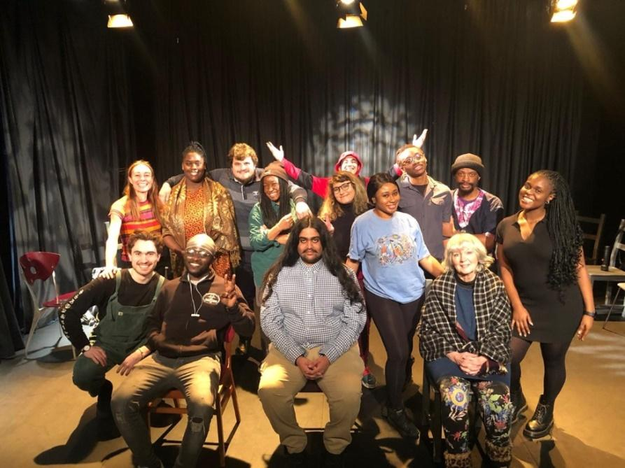

Nature of the Post

This is a vital role within the organisation, with responsibility for day-to-day management, strategic leadership and direction of the Participation Department. The theatre is currently experiencing a period of change as the Executive & Co-Artistic Director is on maternity leave. In the interim, this role has been split into Theatre Manager & Programmer (full time) & Executive Director (part-time). The Head of Participation will work collaboratively with these two postholders and the General Manager to ensure the integration of the participation and artisit programme, giving equal importance to each and where possible seeking opportunities for one to support the other.

This role will require delivery of some of the projects and over-arching management of them all.

Contract | One year full time fixed term contract initially with the expectation of being renewed as a permanent contract subsequently.
Salary | £31,200 gross
Hours | 37.5 hours p/w  Please see note on hours below.
Holiday | 28 days p/a (including public and bank holidays)
Reports to | Interim Executive Director
Responsible for | Participation staff, freelancers and training posts

First Round Interviews | 21st and 22nd September during daytime hours. These interviews will be held via Zoom
Second Round Interviews | These interviews (plus workshop) will be held in person at Blue Elephant Theatre in the last week of September.
Closing Date for Applications | Friday 9th September, midday

PC: A Kin Photography

Duties and Responsibilities

The Head of Participation is responsible for ensuring the following takes place:

Strategic
- Strategic development of the department, including project creation and evaluation, developing partnerships within the wider community, and working in collaboration with Executive and Co-Artistic Director (or interim team) to ensure the work of the whole theatre remains relevant.
- Working in collaboration with the Executive & Artistic Director (or interim team) to ensure the artistic programming of the theatre is relevant to the young people and communities that engage with BET.
- Supporting the strategic development of BET at an exciting time, as it expands capacity and output after multiple lockdowns during the pandemic.

Project Delivery
- The day-to-day effective management of all of the projects, including ensuring compliance with health & safety requirements and safeguarding requirements (both in BET and other settings, including schools and community spaces).
- Leading on the delivery of specific projects including Creative Minds and the Public Health Grant (see full list and description of projects below). More delivery may be required as the needs of the department shift.
- Develop and maintain relationships with schools, ensuring that schools continue their contracts with BET.
- Overseeing in-house and freelance participation staff in delivery of their projects (taking place on evenings and weekends). This includes administrative management, as well as presence at some of the workshops.

Safeguarding
- Acting as Designated Lead Safeguarding Officer for the organisation and ensuring that best practice is being followed at all times.
- Ensuring that staff and volunteers undertake a DBS check and relevant safeguarding training where needed.
- Being a point of contact during each planned activity in case of an emergency.

Finance
- Managing the financial and administrative operations of the Participation department, (in collaboration with the Executive Director), including setting the budgets, monitoring expenditure, requests and receipt of funds & reporting to trustees.
- Identifying financial issues or needs.

Personnel & HR
- HR management and line-management of participation staff members and volunteers (including regular appraisals and assessment).
- In collaboration with the Executive & Co-Artistic Director (or interim team), ensuring staff members have up to date contracts, induction on starting roles, required training, pension paperwork, etc.
- Active involvement in the recruitment of personnel, ensuring opportunities are shared widely and made as accessible as possible.
- Actively promoting equal opportunities throughout the theatre.
- Providing pastoral support for staff members.

Funding
- Working closely with the Executive Director & Co-Artistic Director (or interim team) to create compelling funding applications, linked to the ambitions set out in the business plan, to secure additional funding for Participation activities.
- Supporting Executive & Co-Artistic Director (or interim team) to ensure BET meets or exceeds all the conditions and requirements of our NPO funding from Arts Council England.
- In collaboration with the Executive & Co-Artistic Director (or interim team), developing and maintaining relationships with appropriate funding organisations.
- Research new avenues of funding where needed.
- Contribute to and submit relevant fund applications.
- Ensuring funding offers are accepted in a timely manner, that conditions of funding are met and reports are submitted on time.
- Ensure that invoices have been sent and finance has been received.

Miscellaneous
- Acting as a key holder and supporting where necessary the activities of the rest of the theatre.
- Managing projects as they arise.
- Undertaking any other duties when necessary.
- Undertaking additional delivery of projects to support staff absence, when necessary.
- Supporting the implementation of BET’s Business plan (including Equality Action Plan & Environmental Action Plan), including its aim to be a safe space which supports the expression of creativity. This safe space is:

- Somewhere artists can try new ideas, techniques and approaches, cushioned by BET’s support mechanisms.
- Somewhere local communities, particularly young people, feel safe to express themselves creatively and explore issues troubling them or that arise in their lives. At times, it is a safe space from troubles in their lives and BET staff take safeguarding young people and vulnerable adults extremely seriously.
- Somewhere inequality, discrimination and bullying is neither tolerated nor ignored. BET aims to set a standard for what it means to be a friendly, collaborative workplace which values employees, artists and other workers within BET alike.
- Somewhere audiences feel is “for them” regardless of their background and previous familiarity with the arts.

The Head of Participation has a responsibility to maintain and support this safe space. BET is committed to ensuring all employees find BET a safe space to work within and will give any grievances or concerns due attention.

Note on Hours

Working days are typically Mondays to Fridays from 10am to 6.30pm with an unpaid lunch break, but there is a great deal of flexibility, as weekend and evening work are frequently required.

At present, the post-holder will be expected to work early evenings on Thursday and during the day on Saturday, as necessary. Overtime is not paid, but the post-holder is expected to take Time Off in Lieu as far as is possible

The above list is not exhaustive and reasonable duties may be added to it.

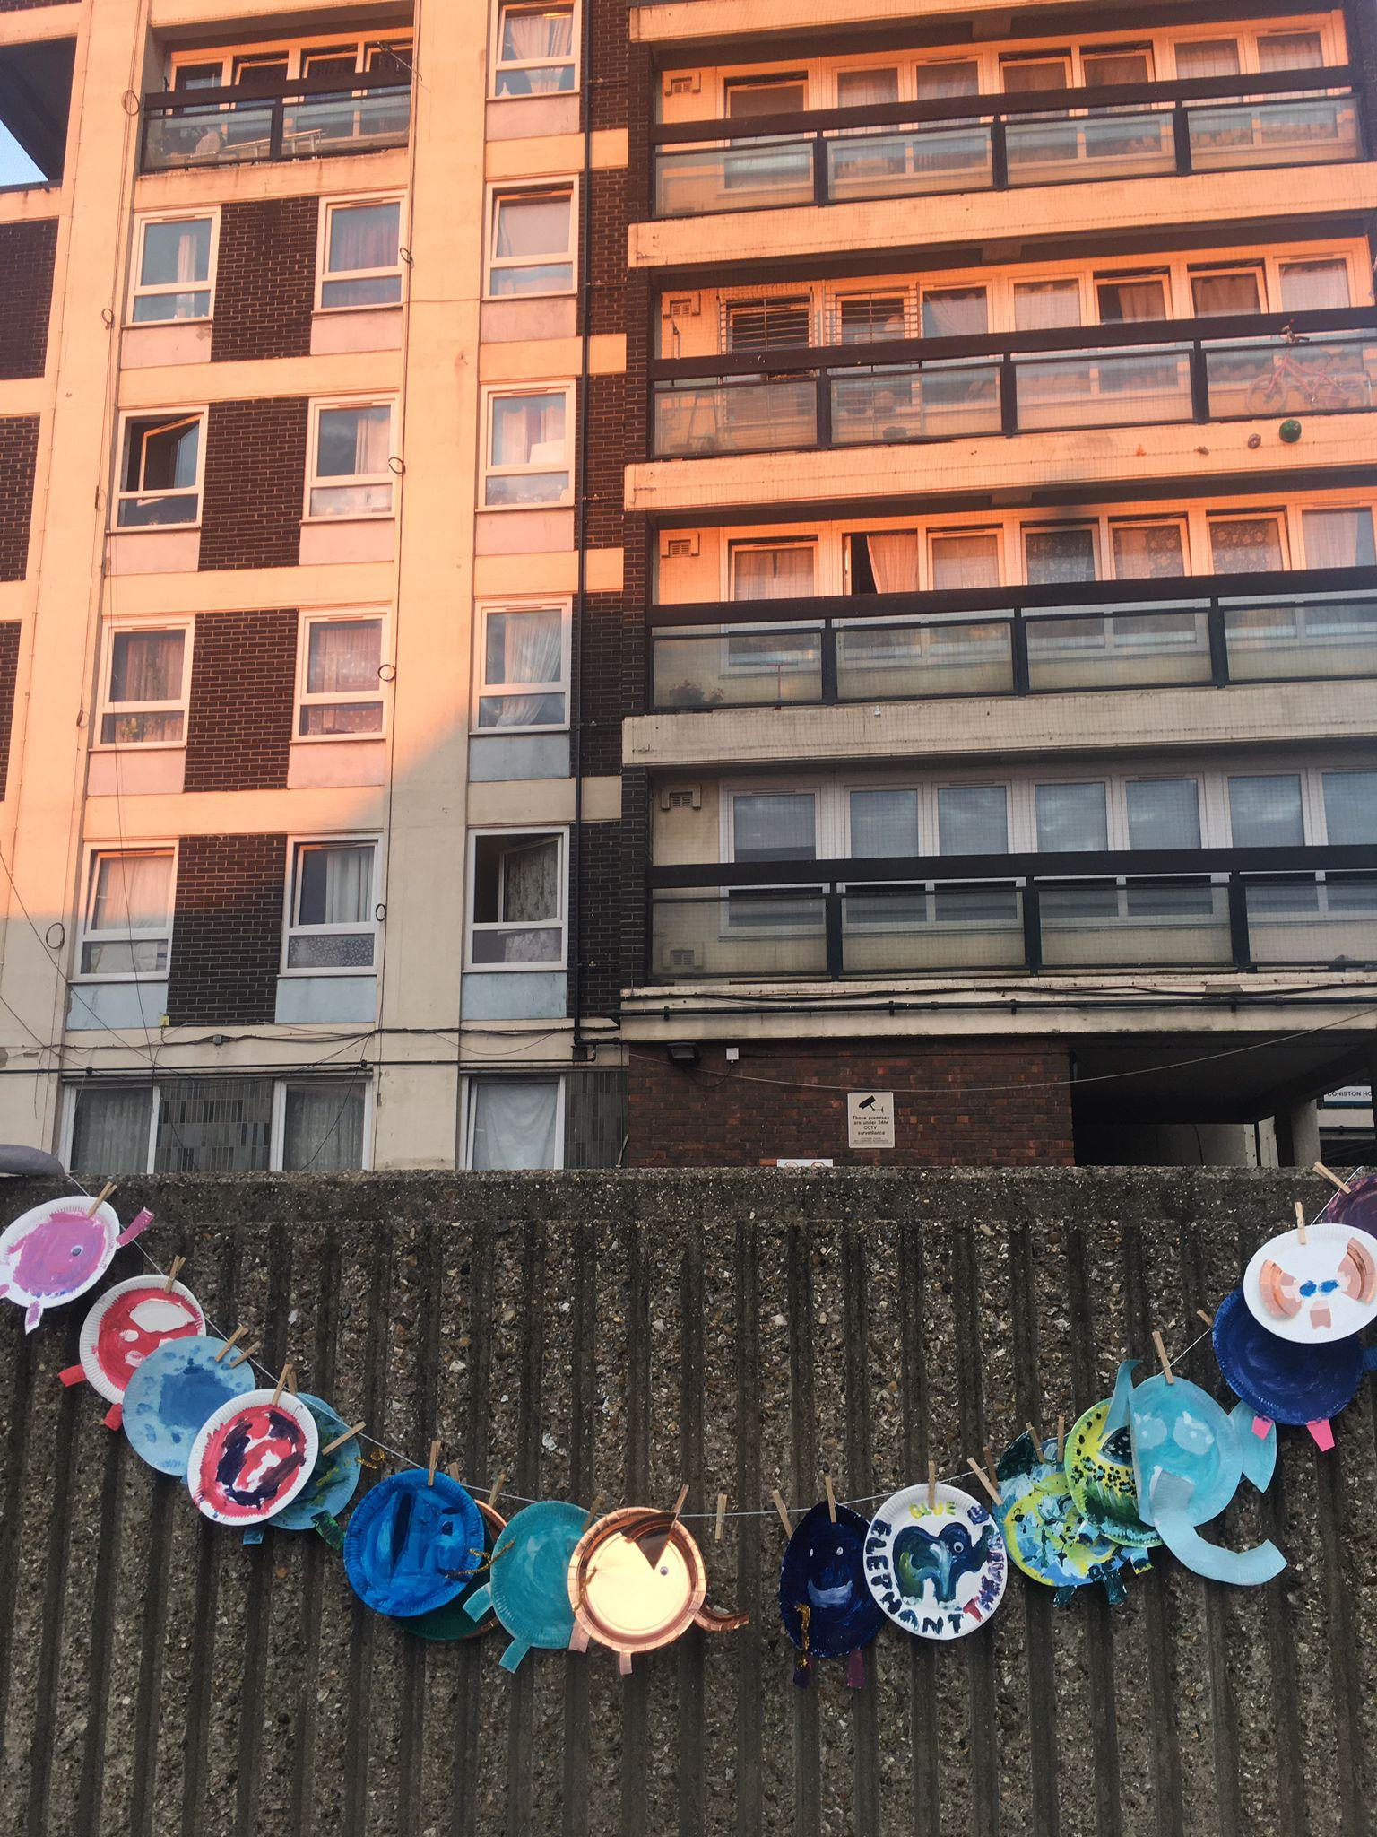

List of Participation Projects

Young People’s Work

Creative Minds | Ongoing primary school-based workshops to support curriculum learning, as well as after school clubs.
Healthy Minds | An arts-based approach to supporting the additional mental health needs of designated young people in a primary school.
Young People’s Theatre | Youth theatre for spanning the ages of 7-18 on Saturdays.
Free to Act | Youth theatre spanning the ages of 7-15 on Thursdays.
Playing Up | Workshops for children aged 1-3 and their adults, focusing on the power of play.
Speak Out | A forum theatre project touring across secondary schools to tackle pertinent issues.

Adults’ Work

Community Play | An arts opportunity for local residents to create meaningful work.
After Hours | An opportunity for hyper-local 18-25 years olds to create community focused theatre.
Public Health Arts | (Parent & Child, Social Dance, Adult Drama): Arts projects for adults to support mental and physical well-being.
Train in Work | A paid training a work opportunity for 18-25 year olds in the art of facilitation.
SELNWK Elephants | Arts projects for adults with acquired brain injury in partnership with Headway.

BET also responds to the needs of the community and creates bespoke ad-hoc work according to need and upon request.

Person Specification

Essential:

- Can demonstrate strong experience working in arts participation role(s) with similar responsibilities (three years minimum).
- Experience of working with under-served communities, who experience barriers to the arts.
- Experience of working in and/or with schools.
- A desire to champion diversity in the arts and active commitment to making the arts accessible to all.
- Experience of responsibility for Safeguarding.
- Strong track record in fundraising, including applications and reporting to trusts and foundations.
- Experience in the development and delivery of projects from first inception, to evaluation, and final reporting.
- Excellent interpersonal and communication skills, including verbal and written communication.
- Experience of managing employees and freelancers with the ability to guide, support and develop, leading by example and setting the highest standards of excellence.
- Experience of financial management.
- Strong administration and IT skills.
- Ability to work under pressure in a busy environment, to take a hands-on approach, and to multi-task in order to meet numerous conflicting deadlines.
- Up to date DBS check.
- Willingness to work flexibly, including evening and weekend working

Desirable:
- First aid training within the last three years.
- Safeguarding trained within the last 3 years.
- Experience of reporting as an Arts Council NPO.

Please note BET's theatre space is wheelchair accessible but our office upstairs is not. We do not want this to deter potential applicants as we would seek to work together to find a practical working solution should the person appointed be a wheelchair user.

To apply, please fill out the application form below. Applications should be emailed to recruitment@blueelephanttheatre.co.uk. If you have any questions or would like a more accessible way of applying, please email info@blueelephanttheatre.co.uk or call 02077010100.

Head of Participation Application Form

Please complete the form below and send it to recruitment@blueelephanttheatre.co.uk by midday on Friday 9th September. Please follow this link to complete a monitoring form which is also requested by

Name:

Address:

Phone number:

Email address:

Have you the right to work in the UK?

Education
Please give details of your formal education, i.e. any schools and college/university you attended (You can also attach a CV instead to give these details)

Dates | Establishment | Courses/Subjects | Qualification/Grades

Do you have any other relevant training/skills?

Relevant work experience
Please begin with your current or most recent employment. Please include any volunteering or work experience that you feel is relevant. (You can also attach a CV instead to give these details)

Name & Address of Employer | Title of Role and Duties | Dates | Part-time/Full-time

Do you need to give notice before beginning this new job?
If so, how long is the notice period?

Statement: Please write a statement of up to 1000 words, with reference to the person specification and job description, explaining why you feel you are suited to the position. This is a vital part of your application and it cannot be considered without this.

Is there anything else you wish us to know about your application? Please also let us know if the interview dates are difficult for you.

Referees
Please provide names and addresses of two references, one of whom should be your current or most recent employer. Please indicate if references may be taken up prior to a job offer.

Referee One | Referee Two
Can be contacted prior to job offer? Y/N | Can be contacted prior to job offer? Y/N

Should you be invited to interview do you have any access requirements? If so, please detail:

Under the Rehabilitation of Offenders Act 1976, are there any convictions which you are required to disclose?

Declaration
I declare that the information contained in this application is correct to the best of my knowledge and understand that any false statement may result in my application being withdrawn or my appointment being terminated.

Signed: Date:

