Additional Information about your visit to Blue Elephant Theatre
We are located at:
59a Bethwin Road (entrance is on Thompson Avenue)
Camberwell
SE5 0XT
Tel: 020 7701 0100
info@blueelephanttheatre.co.uk
When you arrive at the Blue Elephant, the Box Office will be immediately on your left up a couple of steps. Once you have collected or bought your tickets, we will ask you to make your way upstairs to our friendly café area on the first floor, where you are welcome to wait until the show begins. We will make an announcement here when the doors to the theatre will open.
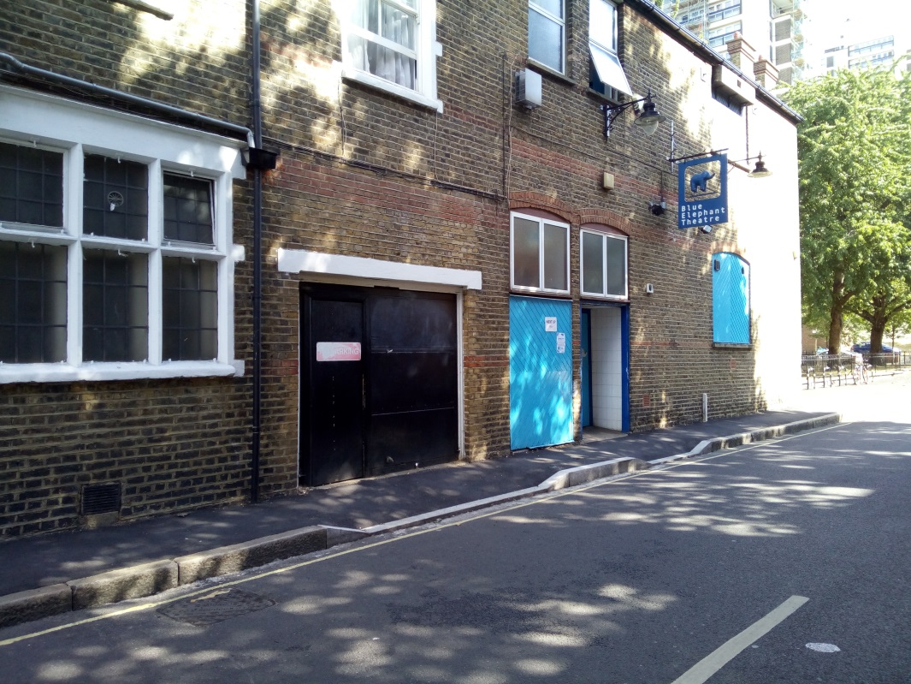

Entrance on Thompson Avenue

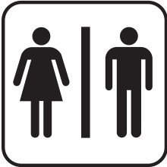 | Male and female toilets are located halfway up the stairs, and an accessible unisex toilet is located on the ground floor.
 | We will generally open the doors to the performance space at the advertised starting time of the performance, so the show may start a few minutes ‘late’. This is because we can be a little tricky to find for the first time, and because of the layout of our venue it can be more difficult to admit latecomers. We advise that you allow a few minutes before and after the performance for this.
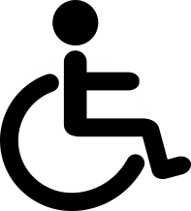 | The theatre on the ground floor is currently accessible for wheelchairs – our upstairs café area is unfortunately not. Please let us know when you are booking if anyone attending in your group has access needs, and we will do our very best to accommodate them.

Frequently Asked Questions:
Can babies come to see the show with the family?
Yes. Children under 18 months can come to shows for free. Please let the Box Office know when booking on 020 7701 0100, if you intend to bring a baby. We have some basic changing facilities, and welcome breastfeeding at our venue. Please speak to a member of staff if you would like further information about this.
Is there somewhere to store my pram/wheelchair/pushchair?
We have very limited space to store pushchairs in our foyer, but please note these are left at the owners’ risk. Larger items can be stored in the bar or theatre office at the customer’s request.
Can children and young people see the show unaccompanied?
We ask all children under 14 to be accompanied by an adult when visiting the theatre. If you have any questions regarding this please call us to discuss on 020 7701 0100.
Is eating allowed in the theatre?
We ask our audience not to bring food into the theatre because it can get a little noisy, water and drinks in plastic cups are fine. Water is freely available at our café.
Can tickets be reserved to be paid for on arrival?
No, advance bookings must be paid for prior to the show.
If I cannot attend a performance, can I get a refund on my tickets?
We're unable to give refunds unless a performance is cancelled. Please give us a call on 020 7701 0100 as soon as possible, as we may be able to exchange your ticket to another production or find an alternative solution.

