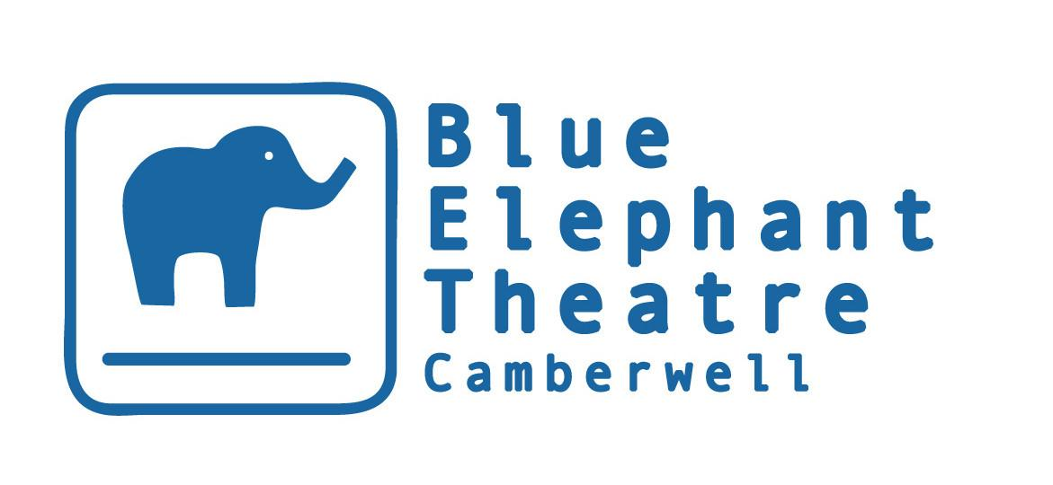

Young People’s Theatre
Co-ordinator

HISTORY & BACKGROUND

Opened in 1999, the Blue Elephant Theatre is a vibrant arts venue that aims to widen access to creative opportunities and thus the benefits and positive impact of the arts. We have vibrant and engaging professional and participation departments and aim to link up both as often and meaningfully as possible. BET became an NPO in April 2018 and has been supported by Southwark Council since it opened. Our work with young people has received significant funding from BBC Children in Need for over a decade, supporting young people in the local community to increase their self-confidence, self-belief and social skills. An opportunity has arisen to run our Young People’s Theatre for an academic year as sick leave cover.

Young People’s Theatre Coordinator

Nature of the post
To administrate and deliver the Blue Elephant Young People’s Theatre. This involves the planning and delivery of weekly workshops for three age groups, working with Young People’s Theatre Assistant(s), volunteers and freelance artist/workshop leaders; acting as a contact for the members, parents/carers and artists; monitoring and evaluation; the co-ordination of all administrative tasks related to Young People’s Theatre including the recruitment of participants, monitoring attendance and pastoral care.

Salary £150/day
Hours 2 days per week during term-time (specifically Fridays and Saturdays, contract for 60 - 70 days in total)
Holiday Statutory holiday entitlement
Probation Period 3 months (with potential to extend to 6 months)
Contract Length September 2021 - July 2022
Pension Option to join our NEST pension scheme (auto-enrolment will also apply if earnings threshold is reached)

Reporting to: Participation & Co-Artistic Director

Deadline for Applications: August 6th (midday)

Project Description
Blue Elephant Theatre’s Young People’s Theatre is an extracurricular drama project for 7 - 18 year olds which uses the arts and drama to build confidence, raise aspirations and allow young people in Southwark to express themselves creatively through free weekly drama workshops funded by BBC Children in Need. Each term culminates in a showcase at our professional theatre.

Inclusive out of school arts learning:
In response to demand from both parents and young people, the Blue Elephant Theatre delivers a consistent programme of out of school arts learning workshops for young people from particularly vulnerable backgrounds. This is particularly true of Young People's Theatre which is funded by BBC Children in Need and which aims to recruit young people who are more disadvantaged than the general population and support them to positive life outcomes.

DUTIES & RESPONSIBILITIES
The Young People’s Theatre Officer will be responsible for the overall success of the project by implementing the project aims, objectives and deliverables. Throughout the delivery of the project the post’s main duties will include:

Project Delivery:
1. To deliver four workshops each Saturday, for 10 weeks each school term, to a group of children and young people aged 7 - 18 from particularly excluded backgrounds. Each workshop group will work towards an original performance at the end of each term.
2. To act as a link between the project and parents, guardians or referring organisations through regular telephone and personal contact.
3. To regularly take the young people on theatre/cultural trips around London, and to support their involvement in the running of the Blue Elephant Theatre via the Youth Board.
3. To ensure that young people from Refugee and Asylum Seeker or Traveller backgrounds, Looked After Children and those with Special Educational Needs or physical disabilities receive ongoing support to access these workshops.
4. To co-ordinate a team of volunteers to support the workshops and manage the role and responsibilities of the Young People’s Theatre Assistant(s).
5. To report any safeguarding concerns to the Designated Safeguarding Lead.

Project Management:
1. To administrate the project fully, ensuring its continuation and ongoing success
2. To uphold the Blue Elephant Theatre’s Safeguarding Policy.
3. To liaise with theatre staff for any immediate issues relating to the project.
4. To meet regularly with the Participation Director for project monitoring and development.
5. To ensure the quality of the project is maintained and increased.
6. Keeping a detailed record of participants and attendance, regularly gathering targets and feedback from participants and keeping a photographic record of workshops and performances.
7. To undertake a Covid-19 Risk Assessment and and adhere to any measures identified as necessary
8. To conduct and document a risk assessment of any showcases or activities outside the theatre before they take place
9. To manage the YPT Budget in conjunction with the Artistic Directors.
10. To ensure consent forms, photography consent forms and monitoring forms are completed for each participant.
11. To lead on writing the annual Children in Need report
12. To obtain, store and use personal data in compliance with data protection laws.
13. To write weekly reports on sessions.
14. To ensure registers are updated
13. To ensure suitable snacks are bought for participants, ensuring there are options available to anyone unable to have certain foods for health, religious or other reasons
14. To ensure Star of the Week prizes and other materials are bought as needed
15. To be responsible for and run Arts Awards when appropriate

GENERAL RESPONSIBILITIES
- Acting as Key holder, including responsibility for opening up and locking when required/agreed
- Supporting keeping Staff & Volunteer details up to date and stored according to best practise data protection guidelines
- Supervising volunteers
- Taking box office bookings over the phone and in person occasionally
- Liaising with users of the theatre space
- Supporting the implementation of BET’s Accessibility Action Plan
- Actively promoting equal opportunities
- Adhering to and implementing the theatre’s Health and safety policies
- Undertaking any other duties reasonably requested
- Supporting the implementation of BET’s Business plan, including its aim to be a safe space which supports the expression of creativity.

This safe space is:

- Somewhere artists can try new ideas, techniques and approaches, cushioned by BET’s support mechanisms.
- Somewhere local communities, particularly young people, feel safe to express themselves creatively and explore issues troubling them or that arise in their lives. At times, it is a safe space from troubles in their lives and BET staff take safeguarding young people and vulnerable adults extremely seriously.
- Somewhere inequality, discrimination and bullying is neither tolerated nor ignored. BET aims to set a standard for what it means to be a friendly, collaborative workplace which values employees, artists and other workers within BET alike.
- Somewhere audiences feel is “for them” regardless of their background and previous familiarity with the arts.

The YPT Coordinator will share a responsibility to maintain and support this safe space. BET is committed to ensuring all employees find BET a safe space to work within and will give any grievances or concerns due attention.

The above list is not exhaustive and reasonable duties may be added to it, especially as this is a new post.

Person Specification

Essential:

- Can demonstrate strong experience working with young people in an educational or arts setting (ideally three years minimum).
- Experience of facilitating arts workshops and session planning.
- Knowledge of best practice and protocols around safeguarding.
- Excellent interpersonal and communication skills, including verbal and written.
- Ability to manage a budget.
- Willingness to undergo a DBS check
- Flexibility, commitment, compassion and consistency when it comes to dealing with the needs of the young people.
- A belief in the role of theatre/arts for positive social change
- A desire to champion diversity in the arts and active commitment to make the arts accessible to all
- Strong administration and IT skills

Desirable
- First aid training within the last three years
- Arts Award training
- Experience of writing funding applications and/or reports
- Good knowledge of key issues relating to education, the arts, public and voluntary sector.
- Experience of working with some of the groups BET engages with, eg young people from underprivileged and migrant and refugee backgrounds, young people at risk of child criminal exploitation, young people living with mental health problems

It would be useful to know if an applicant has had a DBS check or first aid training in the last three years but these are not essential for securing the role, provided you are willing to undergo a DBS check and first aid training once appointed.

Working days are typically Fridays and Saturdays during term-time.

The Blue Elephant Theatre welcomes applications from all sections of the community regardless of race, colour, ethnic or national origins, marital status, sex, sexual orientation, disability or religious beliefs.

Blue Elephant Theatre is committed to widening access to the arts and when recruiting we reserve the right to guarantee interviews to applicants referred by partner organisations provided they meet the essential criteria and complete an application form.

Please note BET's theatre space is wheelchair accessible but our office upstairs is not. We do not want this to deter potential applicants as we would seek to work together to find a practical working solution should the person appointed be a wheelchair user.

To apply, please fill out the application form below – or you can record your answers if you would prefer. Please share footage/recording via wetransfer/google drive links if possible. Applications should be emailed to recruitment@blueelephanttheatre.co.uk. If you have any questions or would like a more accessible way of applying, please email jimmy@blueelephanttheatre.co.uk or call 02077010100.
Young People’s Theatre Coordinator Application Form

Please complete the form below and send it to recruitment@blueelephanttheatre.co.uk by midday on August 6th. Please include “Young People’s Theatre Coordinator Application” in the subject line. Alternatively, you can record your answers if you would prefer, although please keep this no more than seven minutes in length. Please share footage/recording via wetransfer/google drive links if possible to the same email address. Please follow this link to complete a monitoring form which is also requested by August 6th.

Name:

Address:

Phone number:

Email address:

Have you the right to work in the UK?

Education
Please give details of your formal education, i.e. any schools and college/university you attended (You can also attach a CV instead to give these details)

Dates | Establishment | Courses/Subjects | Qualification/Grades

Do you have any other relevant training/skills?

Relevant work experience
Please begin with your current or most recent employment. Please include any volunteering or work experience that you feel is relevant. (You can also attach a CV instead to give these details)

Name & Address of Employer | Title of Role and Duties | Dates | Part-time/Full-time

Do you need to give notice before beginning this new job?
If so, how long is the notice period?

Statement: Please write a statement of up to 600 words, with reference to the person specification and job description, explaining why you feel you are suited to the position

Referees
Please provide names and addresses of two references, one of whom should be your current or most recent employer. Please indicate if references may be taken up prior to a job offer.

Referee One | Referee Two
Can be contacted prior to job offer? Y/N | Can be contacted prior to job offer? Y/N

Should you be invited to interview do you have any access requirements?* If so, please detail:

*We anticipate first interviews being held virtually but second interviews may take place in person

Under the Rehabilitation of Offenders Act 1976, are there any convictions which you are required to disclose?

Declaration
I declare that the information contained in this application is correct to the best of my knowledge and understand that any false statement may result in my application being withdrawn or my appointment being terminated.

Signed: Date:

